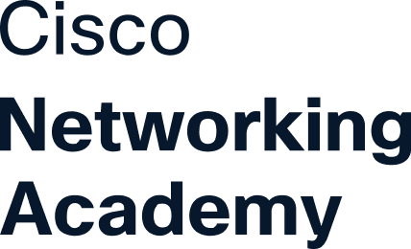
This certificate is awarded to
Hema Manikanta Kumar Ravi

for successfully completing
Linux 2
offered by KL University Hyderabad
through the Cisco Networking Academy program.
Dr JAYARAM BOGA
Instructor
KL University Hyderabad
04
Oct
2026
Completion Date
Cert ID: 0a593fc2-5878-4ff6-8ab2-e47d9ed2c37a

